New AIMA features in version 2.7.3

Contents

General 1

Tenant 1

Tenant Associations 2

Site 3

Human Resources 3

Document viewer 3

Administrative 9

Pontaj Generation 10

Document viewer 11

Admin 13

Tenant Associations 13

Site history 13

Blocked Weeks 14

OLAP Cubes 14

New Aima Configuration keys 15

Navigation Tree restructuring 16

Tracking fields for employees 17

# General

## Tenant

To accomodate for the existance of two company entities for accesa and possibly more in the future (Accesa IT Consulting and Accesa IT Systems), a new entity has been added to AIMA, named **Tenant**. Similar to the department entity, the tenant entity is used for grouping employees based on a common criteria, namely the company under which they have their work contract.

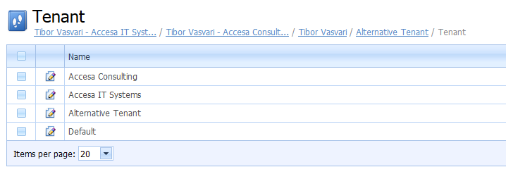

Most of the functionality in AIMA works the same after the addition of the tenant entity. Most of the changes merely provide means of filtering employees, activities, projects, expenses and other related entities based on a tenant.

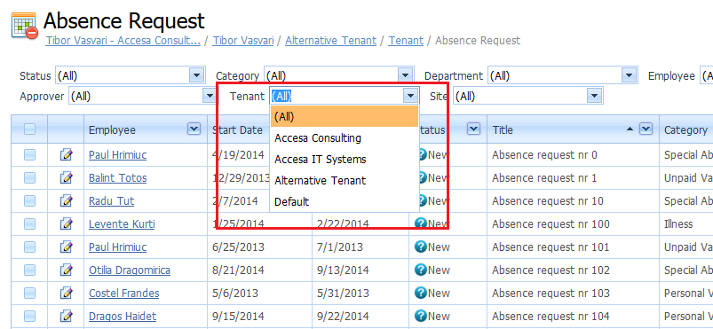

## Tenant Associations

With the introduction of **Tenants** to AIMA, a new entity has been created to link employees to these tenants, namely **Tenant Associations**. Similar to Employee Assignations, a Tenant association defines a colaboration between an employee and a tenant for a continuous period of time. The **Date Acquired** and **Date Left** now compute their value from tenant associations.

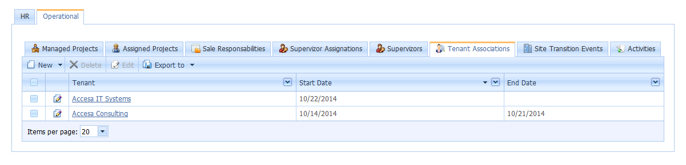

When an employee switches tenants, a new tenant association should be created. The start date of the new tenant association will be used to set the end date of the previous association, if this one does not yet have its end date sate. To indicate that the emploee has not left the company, but merely switched tennants, the difference between such associations should be one date. For example, an employee belongs to the Accesa Consulting tenant since 10/14/2014 and up to 10/21/2014. On 10/22/2014 he transitions to Accesa IT Systems, but is still considered part of the company (he did not leave the comapny on 10/21/2014). Similarly, date acquired will use the 10/14/2014 date, since that is when the employee joined the company (not the tenant) and the end date will be empty, since the latest tenant assignation does not have a set end date.

Note that the out of office leave days calculation does not take tenant switching into account, meaning that changing an employee’s tenant (by creating a new tenant association) **does not change his number of days off**.

## Site

To accomodate for the acquisition of a new company location in Cluj Napoca, the job location (city name) has been replaced with the **Site** entity. The difference between the two is that site also contains the address of the site, meaning that multiple sites can be located in the same city.

# Human Resources

## Document viewer

A document viewer has been added to AIMA, through a collaboration with the company’s intranet, allowing users to view and edit documents directly from within the browser. To view or edit a document within the browser, simply navigate to the document (either list view or detail view), select the desired document and use the ***View Document*** action as in the image below.

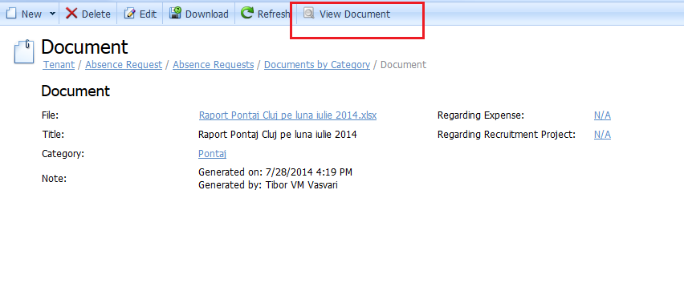

Afterwards a popup will be displayed, requesting you to log into the intranet (only the first time, you will remain logged in while the browser is open). If you have requested your browser to remember your login information (or you are using Chrome) this popup will not be displayed.

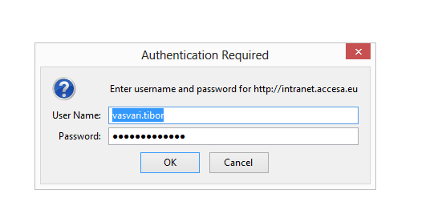

After you have logged in, the document will be displayed within the popup.

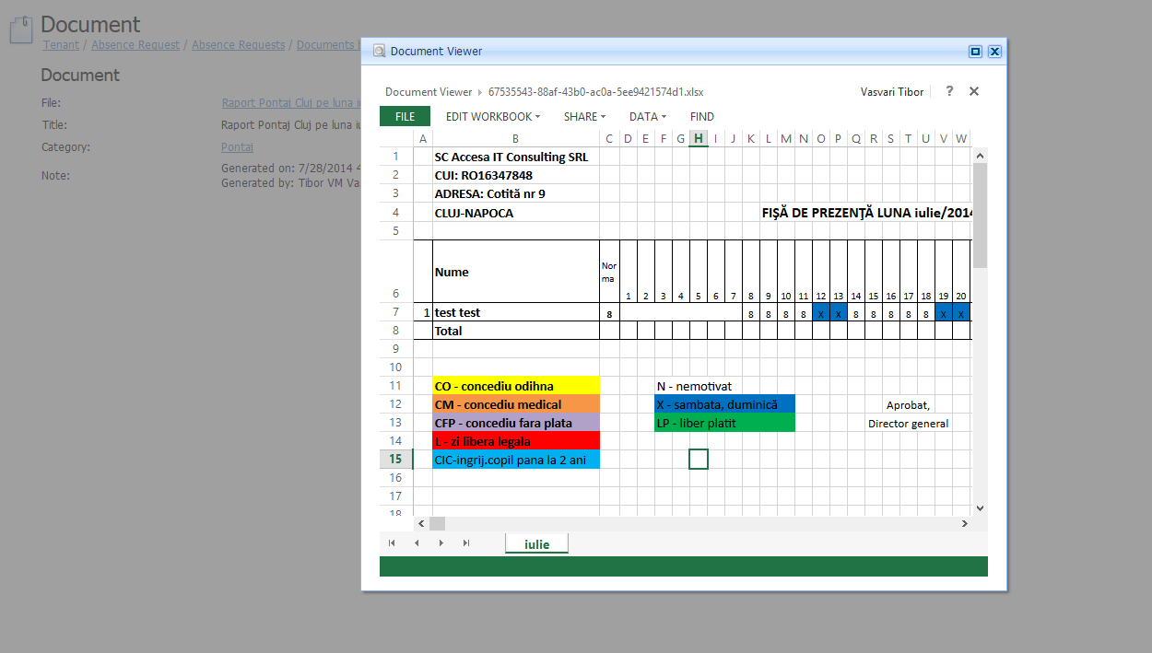

After you have finished editing the document, save the document and exit the popup. The document will be updated in AIMA. Remember to cancel your changes before closing the popup if you do not want to save them, as this could cause errors in some cases.

Note that the document viewer can open word documents, excel files, pdfs and more, but cannot open images. You can still download the document locally and view/edit it there by using the **Download** action.

## Tracking fields for employees

Tracking fields have been added to employees to allow viewing when they were created and updated and by whom these actions were performed. The fields are made available as columns on most employee detail views and can be made visible by dragging them from the field chooser (right click on a column’s title and choose field chooser to display the field chooser).

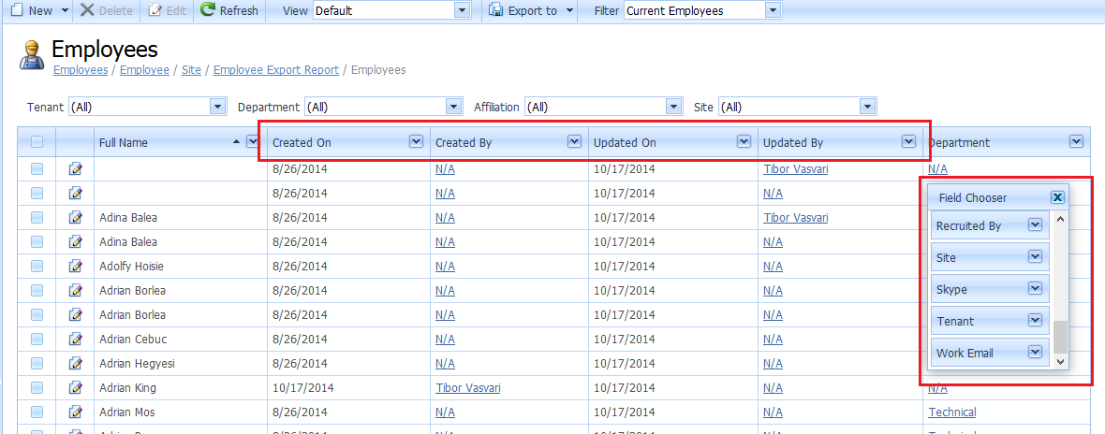

## Work Anniversary and Feedback Discussion Date

A dedicated view has been added to the HR Dashboard that allows viewing upcoming work anniversaries. This view can be found by going to Human Resources -> Dashboard in the navigation tree. The view will be located below the birthday lists.

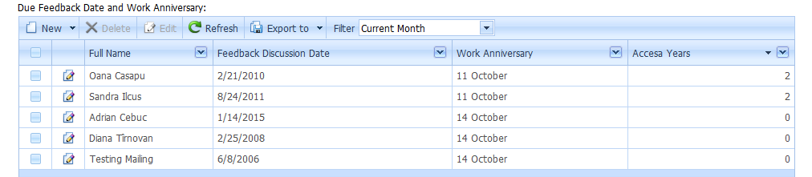

The view will display those employees who either have their feedback discussion for the given month or will celebrate their work anniversary this month. The date for both events is displayed in the columns, as well as the number of years the employee will celebrate within the company. A filter is available at the top of the view that allows switching from the current month to the next month.

## Recruited by field on employee

A new field has been added to employees, named Recruited By, which indicates which employee (usually human resources employee) recruited or hired the employee.

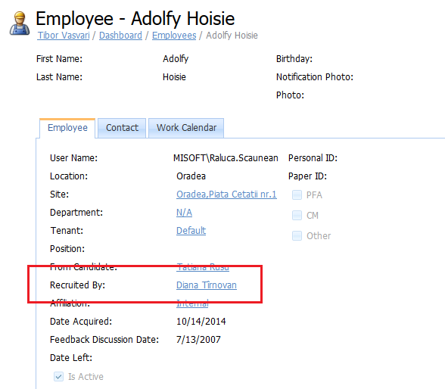

## Candidate Conversion Update

The candidate conversion process has been updated. Now, when converting a candidate, the initial details of the new employee (username, date acquired, feedback discussion date, etc.) will be given a suggested value by AIMA. You will be redirected to the employee’s detail view, allowing you to edit these details before saving. If you wish to cancel the conversion, simply choose **Cancel** and no information will be saved.

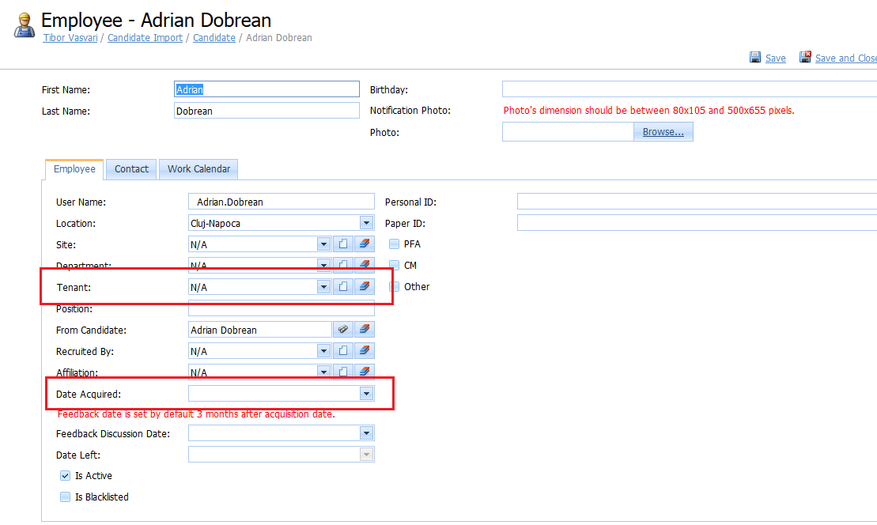

Make sure to set the Tenant and the Date Acquired fields properly, as these will be used to create the first **Tenant Association** for the employee. Afterwards they cannot be edited from here and you will have to edit the Tenant Association to alter these values. After saving, if no other value is set, the feeback discussion date will be set to the date of acquisition + 3 months.

## Blacklisted Employee

AIMA now provides the ability to blacklist an employee. To do so, simply go to the detail view of the desired employee, enter edit mode and set the **Is Blacklisted** flag to true. This will also set the candidate from which the employee has been converted to blacklisted, making sure that they will not be recruited again. If no such candidate exists, a new candidate will be created with the employee’s information and then be set to blacklisted.

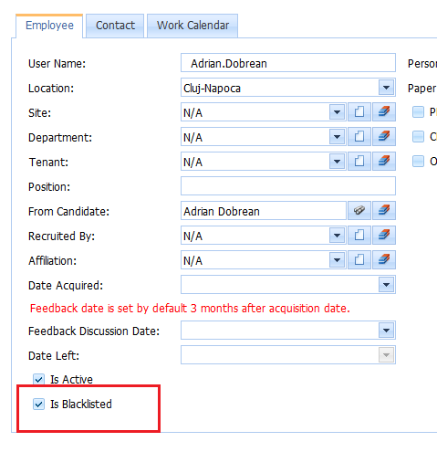

## Employee fluctuation report

Two new views have been added to the Employee Report. These views are the Employee Tenant Associations and Employee fluctuation views. The tenant association view shows a history of all the tenant associations (and tenant transitions). This can be used to quickly view employees who have migrated from one tenant to another.

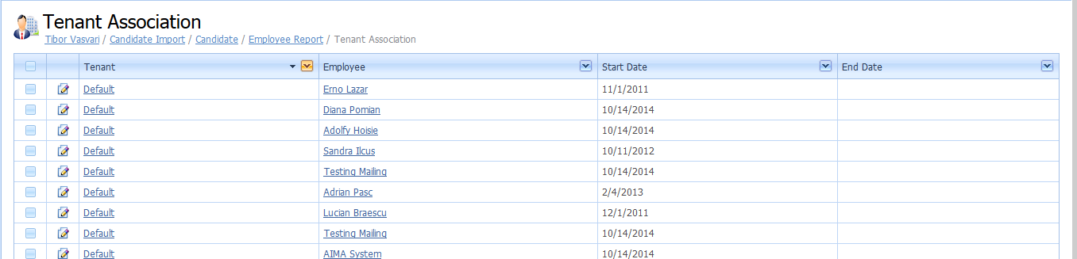

The second view, named Fluctuation Report, is a pivot view containing fluctuation data for employees. It displays the number of employees hired for a given month, as well as those who have left he company, for all the months of a year and for all years of the company. Note that this functionality might still require fine tunning.

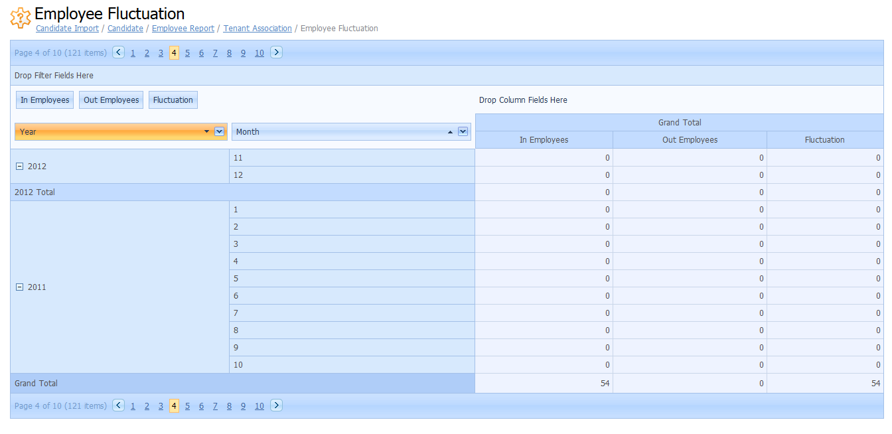

# Administrative

## Pontaj Generation

With the addition of **Tenants** and **Sites**, the pontaj generation process has been updated. Now you can generate a separate pontaj document for each site and for each tenant.

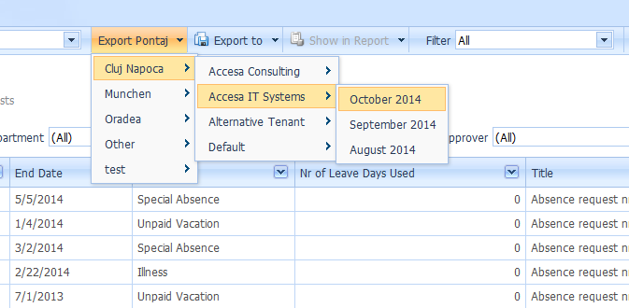

First, select the site for which you want to generate the pontaj. Then select the tenant for which you are generating the pontaj. Lastly select the month for which you want the pontaj to be generated.

Only the employees that are assigned to the given site and for the given tenant on the selected month will be included in the document. If an employee has switched tenants this month, he will appear in the pontaj document for both the tenants for that month. For example if he belonged to Accesa Consulting up to 14th of october and afterwards to Accesa IT Systems, then he will appear in the pontaj document for Accesa Consulting up to the 14th of october, after which he will be displayed as if he left the company, and in the pontaj document for Accesa IT Systems starting on the 15th of octomber, appearing as if he had started working for that company on that date.

Furthermore, the company’s information (CUI and company name) and the site’s city and address will be added automatically for each generated pontaj document according to the choices made. Make sure to set these values before generating documents to make sure they are valid.

## Document viewer

A document viewer has been added to AIMA, through a collaboration with the company’s intranet, allowing users to view and edit documents directly from within the browser. To view or edit a document within the browser, simply navigate to the document (either list view or detail view), select the desired document and use the ***View Document*** action as in the image below.



Afterwards a popup will be displayed, requesting you to log into the intranet (only the first time, you will remain logged in while the browser is open). If you have requested your browser to remember your login information (or you are using Chrome) this popup will not be displayed.



After you have logged in, the document will be displayed within the popup.



After you have finished editing the document, save the document and exit the popup. The document will be updated in AIMA. Remember to cancel your changes before closing the popup if you do not want to save them, as this could cause errors in some cases.

Note that the document viewer can open word documents, excel files, pdfs and more, but cannot open images. You can still download the document locally and view/edit it there by using the **Download** action.

# Admin

## Tenant Associations

With the introduction of **Tenants** to AIMA, a new entity has been created to link employees to these tenants, namely **Tenant Associations**. Similar to Employee Assignations, a Tenant association defines a colaboration between an employee and a tenant for a continuous period of time. The **Date Acquired** and **Date Left** now compute their value from tenant associations.



When an employee switches tenants, a new tenant association should be created. The start date of the new tenant association will be used to set the end date of the previous association, if this one does not yet have its end date sate. To indicate that the emploee has not left the company, but merely switched tennants, the difference between such associations should be one date. For example, an employee belongs to the Accesa Consulting tenant since 10/14/2014 and up to 10/21/2014. On 10/22/2014 he transitions to Accesa IT Systems, but is still considered part of the company (he did not leave the comapny on 10/21/2014). Similarly, date acquired will use the 10/14/2014 date, since that is when the employee joined the company (not the tenant) and the end date will be empty, since the latest tenant assignation does not have a set end date.

Note that the out of office leave days calculation does not take tenant switching into account, meaning that changing an employee’s tenant (by creating a new tenant association) **does not change his number of days off**.

## Site history

A history of an employee’s site transitions is available in each employee’s detail view. This history is presented in the form of a list of site transitions, with a Site indicating the former job location of the employee, a timestamp indicating the date since when he has worked at that site and the employee who triggered the change. When the **Site** of an employee is changed, a new transition event is added to his site history.

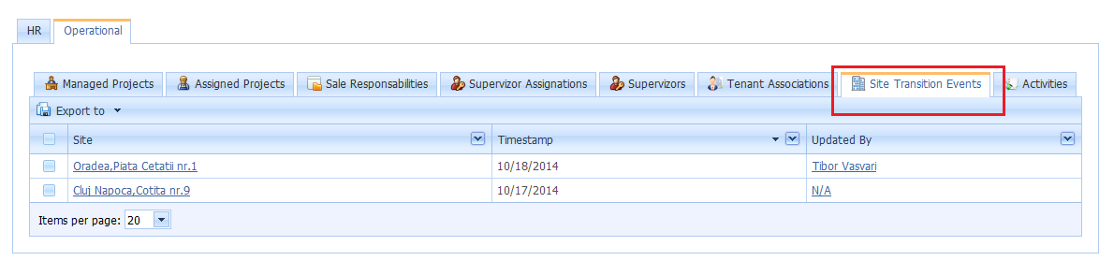

## Blocked Weeks

A new functionality called blocked weeks has been added that allows blocking a period of time equal to a week. During a blocked week no activities can be created or edited, making sure that no unreviewed changes can occur.

To create a blocked week, go to the **Admin** section of the navigation tab and open the **Blocked Weeks** view. From there, use the **New** action to create a new blocked week.

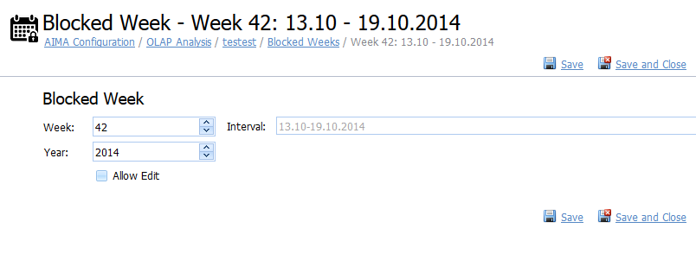

First select the **year** for the week, if the year does not already match the desired year, then select a **week number** from within the year. In the **interval** field in the right side of the view the date intervals between which the week takes place is displayed to help you identify the desired week.

Finally, to indicate that no more activities can be created or updated for the week, set the **Allow Edit** field to false. If you need to unblock the week, simply set the field back to true.

**NOTE** that this functionality is **NOT RELATED TO** the closed month functionality.

## OLAP Cubes

The OLAP cube functionality has been restored. Cubes can now once again be viewed in AIMA in the reports section of the navigation tree. Layout actions have been added to allow saving the current layout as well as reseting the layout to the default state.

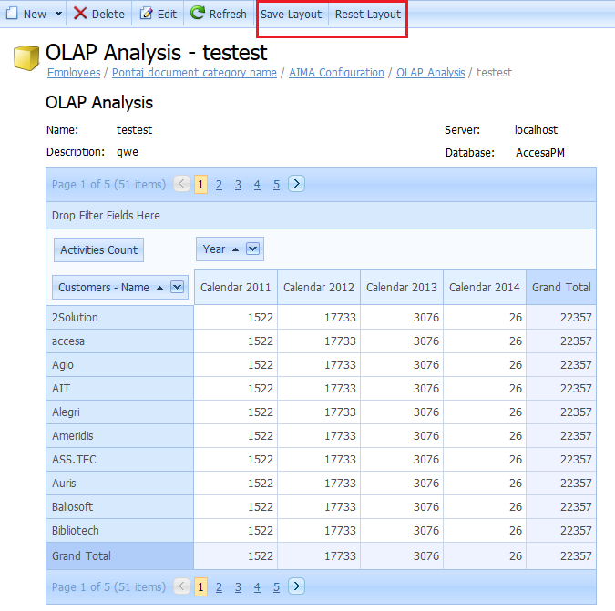

## New Aima Configuration keys

Two new keys have been added to the AIMA configurations that deal with document generation, namely „***Pontaj document category name”*** and „***Profile document category name***”. These keys are used to map the document category used in the pontaj generation process, respectively the one used in the profile generation process. By setting their name to the name of a different document category you can change the category of the documents generated by these features. Note that if a category with the given name does not exist, one will be created the next time a document is generated.

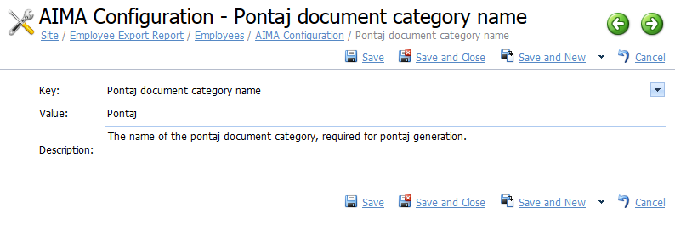

Furthermore, several keys were added to allow individual mailing destinations and sources for the various notification message types within the application. The keys are as follows:

* Employee IBANNotification destination email
* Employee IBANNotification generation email
* Income sheet notification destination email
* Income sheets generation email
* Email campaign generation email
* Employee conversion notification destination email
* Employee conversion generation email
* Absence notification generation email
* Absence notification destination email
* Business trip notification destination email
* Business trip notification generation email
* Expense notification generation email
* Expense notification destination email

Lastly, a key for specifying the default tenant to which employees are assigned to upon creation is provided, namely the ***„Default tenant name”*** key.

## Navigation Tree restructuring

The navigation tree has been restructured lightly to be clearer and of greater use to the users. The area most notably restructured has been the configuration area, now named admin area.

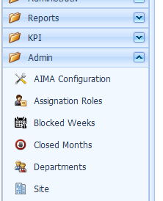

## Tracking fields for employees

Tracking fields have been added to employees to allow viewing when they were created and updated and by whom these actions were performed. The fields are made available as columns on most employee detail views and can be made visible by dragging them from the field chooser (right click on a column’s title and choose field chooser to display the field chooser).

